Esther-Group 10
MA5781 Project

Table of Contents
- Abstract
- Introduction
- Time-Series Plot of CPIAUCSL
- STL Decomposition of CPIAUCSL
- Stationarity Tests
5.1. Augmented Dickey–Fuller Test
5.2. KPSS Test for Level Stationarity
- ACF and PACF Analysis of Differenced Series
6.1. ACF of Differenced CPIAUCSL
6.2. PACF of Differenced CPIAUCSL
- ARIMA Model Specification
7.1. Model Estimation and Coefficient Diagnostics
7.2. In-Sample Forecast Error Measures
- Forecast for CPIAUCSL
- Overall Project Summary
- Answers to Research Questions
- Conclusion
- R Code and Methodology

Abstract
This project examines the long-term behavior of the U.S. Consumer Price Index for All Urban Consumers (CPIAUCSL). Through graphical exploration and decomposition via STL, we identify a strong upward trend with only minor seasonal fluctuations. Formal unit root tests—the Augmented Dickey–Fuller (ADF) and KPSS tests—confirm that the series is nonstationary. In response, we apply appropriate differencing and estimate an ARIMA(0,2,3)(0,0,2)[12] model. The fitted model, supported by favorable error metrics and residual diagnostics, is then used to generate forecasts that extend the upward trend while quantifying forecast uncertainty.

Introduction
Economic time-series data such as the CPI play a critical role in assessing inflation, consumer behavior, and overall economic performance. The CPIAUCSL series, which tracks changes in consumer prices from the late 1950s through the 2020s, provides valuable insights into long-term trends and short-term fluctuations in price levels. Given its cumulative nature, the series exhibits persistent nonstationarity, which complicates forecasting efforts. This report outlines the analytical process—from initial visualization and decomposition through stationarity testing to model estimation and forecasting—employed by Group 10 to rigorously analyze the CPIAUCSL series.

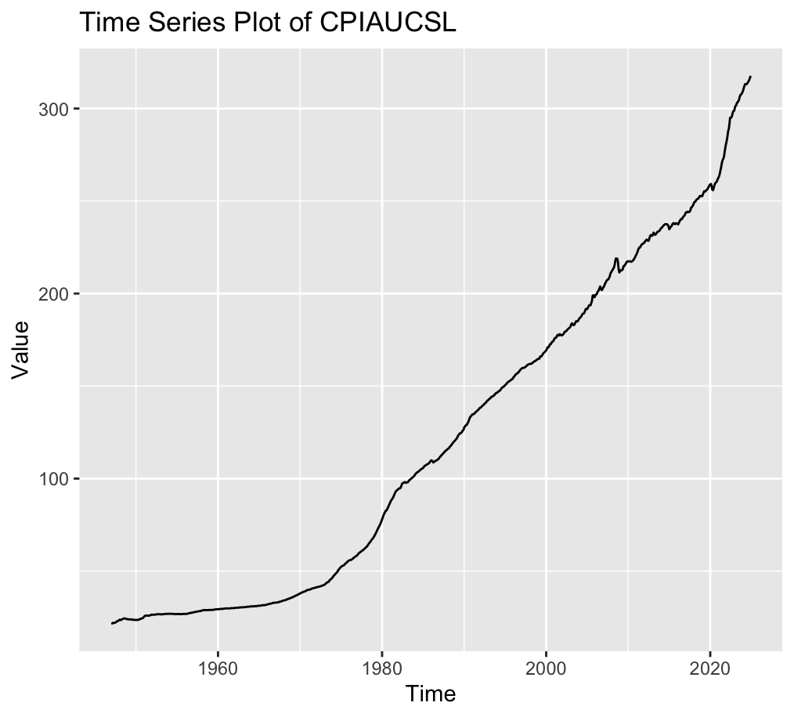
Time‐Series Plot of CPIAUCSL
- This chart shows the U.S. Consumer Price Index for All Urban Consumers (CPIAUCSL) over time (roughly from the late 1950s to the 2020s).
- You can see a steady upward trend—the CPI starts at a relatively low level (under 30 or 40 in the 1950s) and grows to over 300 by the early 2020s.
- CPI is nonstationary: it does not fluctuate around a constant mean but rather exhibits a long‐term rise, reflecting persistent inflation over many decades.

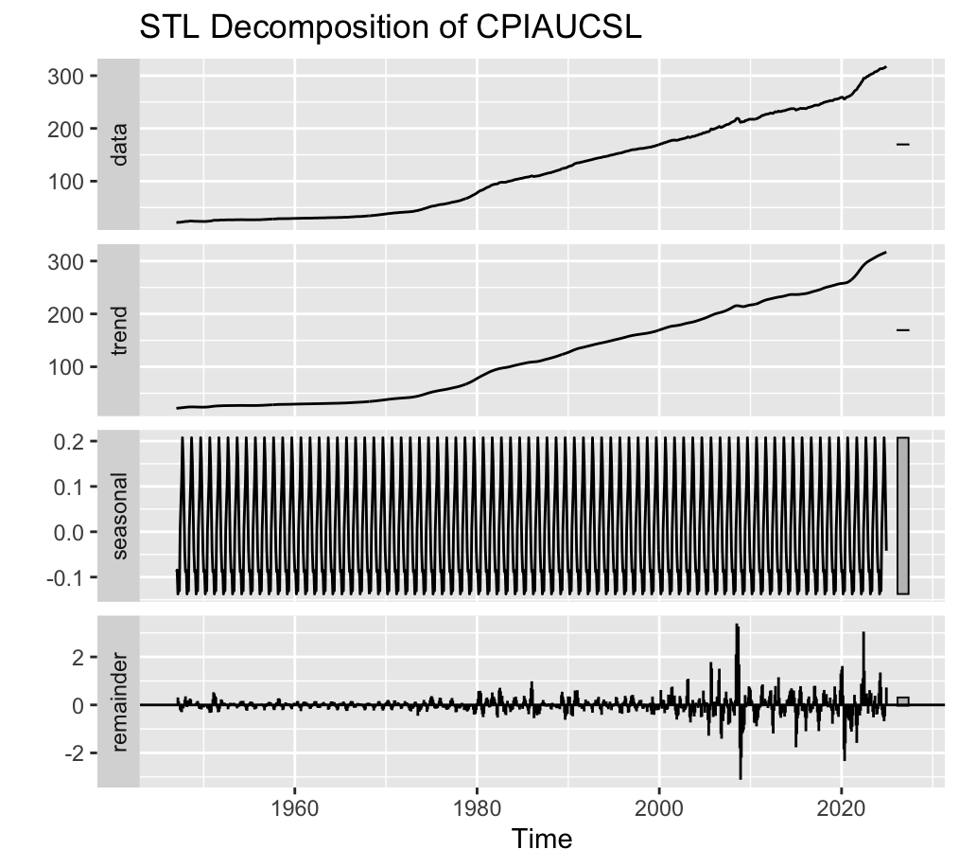
STL Decomposition of CPIAUCSL
- STL decomposition breaks a time series into trend, seasonal, and remainder (irregular) components.
- Data panel: The raw CPI series, again showing the long‐run upward movement.
- Trend panel: A smoothed version of that rise—notice how it closely mirrors the overall shape of the data, confirming that trend dominates CPI’s behavior.
- Seasonal panel: A repeating pattern with a fairly small amplitude (around ±0.1–0.2 on the plot), indicating that although there is some seasonality in CPI, it’s not large relative to the overall level.
- Remainder panel: The part left over once trend and seasonality are removed. Most observations stay within about ±2, so the remainder is relatively small. There are a few spikes (2020–2021), reflecting unusual shocks or outliers (such as the pandemic).
Overall Interpretation
CPIAUCSL is heavily trend‐driven, which is what we’d expect from a cumulative price index. The STL decomposition confirms that CPI’s changes are dominated by a steady, long‐term rising trend and that the seasonal effect is quite small relative to that trend. Short‐term shock events appear in the remainder component, especially in more recent years, indicating unusual movements not explained by normal trend or seasonality.

Augmented Dickey-Fuller Test

data: ts2
Dickey-Fuller = -0.7827, Lag order = 9, p-value = 0.9632
alternative hypothesis: stationary

KPSS Test for Level Stationarity

data: ts2
KPSS Level = 13.134, Truncation lag parameter = 6, p-value = 0.01

1. Overview of the Tests

Augmented Dickey-Fuller (ADF)
- Null Hypothesis (H0​): The series has a unit root (i.e., is nonstationary).
- Alternative Hypothesis (H1​): The series is stationary (no unit root).
If the test statistic is sufficiently negative (below a critical value) or the p-value is below a chosen significance level (0.05), we reject the null in favor of stationarity.

KPSS (Kwiatkowski–Phillips–Schmidt–Shin)
- Null Hypothesis (H0​): The series is stationary (around a deterministic level or trend).
- Alternative Hypothesis (H1​): The series is nonstationary (has a unit root).
Here, if the test statistic is large and the p-value is small (under the significance threshold), we reject the null of stationarity.
2. Reported Results
- ADF Statistic: -0.7827
- p-value: 0.9632
Since the p-value is much larger than 0.05, we fail to reject the null hypothesis of a unit root. This suggests that, according to the ADF test, ts2 is likely nonstationary.
- KPSS Statistic: 13.134
- p-value: 0.01 (or smaller)
Because the p-value is at or below the usual 0.05 threshold, we reject the null hypothesis of stationarity. In other words, the KPSS test also indicates that ts2 is not stationary.
3. Interpreting the Combined Outcome
When using ADF and KPSS together, the most common reading is:
- ADF fails to reject nonstationarity
→→ The data likely has a unit root.
- KPSS rejects stationarity
→→ The data is nonstationary.
Both tests point in the same direction: your series ts2 appears to be nonstationary as currently analyzed.
4. Practical Implications
Given that ts2 is nonstationary:
- Differencing: A typical solution is to difference the series once or more until it appears stationary. For instance, diff(ts2) or diff(ts2, differences = 2) might yield a stationary series.
- Transformation: If the data exhibit strong trends or changing variance, one might also consider a log transform or other stabilizing transformations (depending on the data context).
- Model Choice:
  - Nonstationary data typically needs an ARIMA model with an appropriate differencing order dd.
  - Alternatively, if a trend or seasonality is known, one may use a trend + ARMA or a seasonal ARIMA structure.
5. Summary
- The ADF test (p = 0.9632) indicates a failure to reject the null of a unit root, implying nonstationarity.
- The KPSS test (p = 0.01) rejects the null of stationarity, also implying nonstationarity.
- Conclusion: ts2 is very likely nonstationary in its current form. Further differencing or other transformations are typically required before applying many time-series models that assume stationarity.

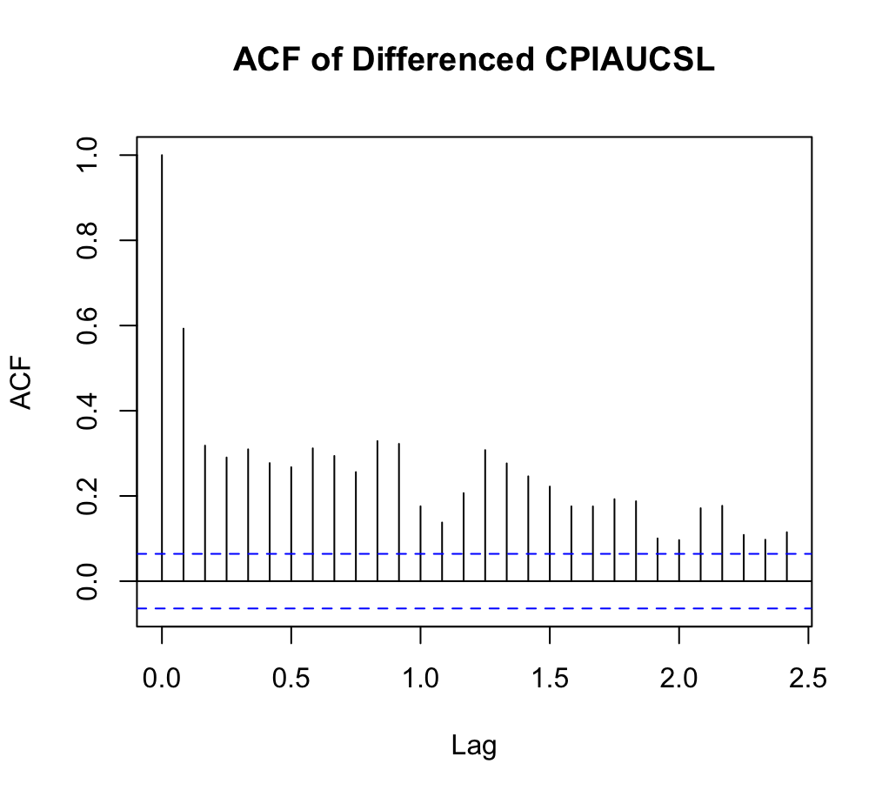

ACF of Differenced CPIAUCSL
CPIAUCSL is the CPI (Consumer Price Index) series; here we have the Autocorrelation Function (ACF) of its first difference. Since CPI is strongly trending (as seen in earlier plots), differencing is often needed to induce stationarity.
Key Observations:
We’ll see a large spike at lag 1—this is typical for many economic time series once differenced (the newly differenced values remain correlated with their immediate past). After lag 1, the autocorrelation gradually diminishes and mostly stays within or close to the significance limits. The slow taper in the bars suggests mild autocorrelation, but not necessarily anything high‐order.
Interpretation:
The strong correlation at lag 1 often indicates a simple MA(1) or AR(1) pattern in the differenced data. If the ACF tails off slowly, it can also suggest a mixture of AR and MA terms, but typically we would also look at the PACF (below) for confirmation.

ACF (Autocorrelation Function)
- Large Spike at Lag 1
Notice that the first bar at lag 1 towers above the significance band (the dashed lines). This indicates that once the series has been differenced, the new (“lag‐1”) observations are still strongly correlated with each other.
- Other Lags
Beyond lag 1, most autocorrelations hover near zero or within the significance bounds. This suggests that the short‐term correlation (particularly at lag 1) is the main feature in the differenced inflation data.
- Interpretation
A single prominent spike at lag 1 in the ACF (with the rest decaying or staying near zero) often points to an MA(1) component in the differenced series or simply a low‐order ARIMA process overall.

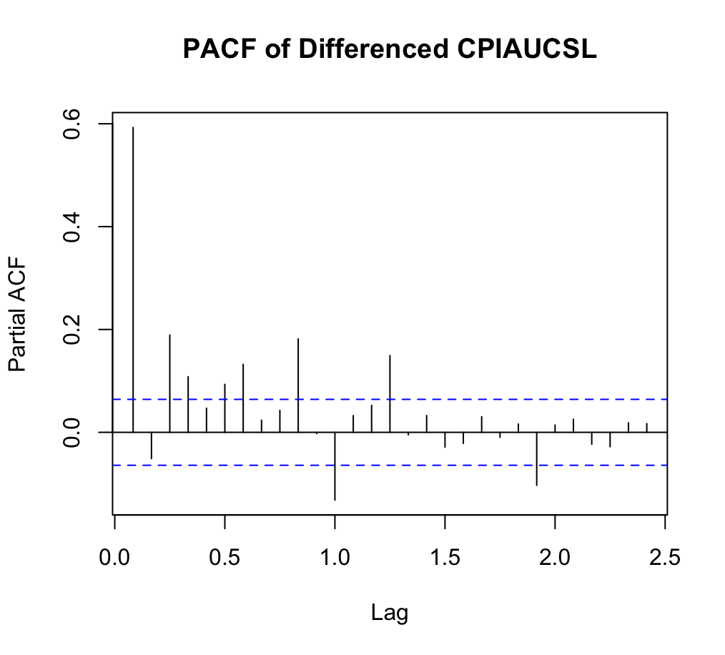

PACF of Differenced CPIAUCSL
The Partial Autocorrelation Function of CPI after differencing. Like the ACF, but it measures the correlation of the series with its own lags net of intervening lags.
Main Observations:
Often, a large spike at lag 1 in the PACF means an AR(1) effect is present in the differenced series. If the PACF at lag 1 is big and then everything beyond lag 1 is small (within bounds), that also indicates a fairly low‐order AR model might capture the dynamics. The fact that the partial autocorrelations for lags 2, 3, etc., do not stand out suggests there is no strong higher‐order AR component.
Interpretation:
Taken together with the ACF, the picture is consistent with something like an ARIMA(1,1,0) or perhaps an ARIMA(1,1,1) (we would check the ACF for possible MA(1) behavior), but generally it’s a low‐order process in the differenced data.

PACF (Partial Autocorrelation Function)
- Behavior at Lag 1
If the partial autocorrelation at lag 1 is not especially large or quickly drops to near zero for subsequent lags, it suggests that there may be only a mild AR component in the differenced data.
- Scattered Mild Spikes
We might see small positive or negative bars at various lags, but many (perhaps all) remain within the dashed significance lines.
- Interpretation
When the PACF does not show strong spikes beyond lag 1, it typically means the data do not exhibit a pronounced AR(2) or higher AR structure in the differenced series. Taken together with the ACF, this might point to something like an ARIMA(0,1,1) or ARIMA(1,1,1) or a similarly low‐order model. One would compare candidate models using further diagnostics (AIC, residual checks).

ACF and PACF of Differenced CPIAUCSL

ACF
- Strong Autocorrelation at Lag 1
Again, the first bar is quite large—typical for an I(1) economic series once differenced. It means ΔCPIt is correlated with ΔCPIt−1​.
- Gradual Diminishing
After lag 1, the bars gradually diminish but do not necessarily drop to zero immediately. Some mild correlation persists out to lags 5 or 6, but many remain near (or below) the significance threshold.
- Interpretation
The strong lag‐1 correlation suggests that just differencing the series is not enough to eliminate all correlation—there may be an MA(1)‐type effect in the differenced data, or possibly a combination of AR/MA terms if the correlations die off gradually.

PACF
Dominant Lag 1 Spike
Typically, a big spike at lag 1 in the PACF indicates a possible AR(1) effect in the differenced series.
Subsequent Lags
If the bars for lags 2, 3, etc. are small or remain within the significance bands, it means there is not a strong higher‐order AR pattern.
Interpretation
Seeing a pronounced lag‐1 spike in both ACF and PACF can mean different things depending on the exact pattern:
ACF large at lag 1 + PACF large at lag 1 often points to an ARIMA(1,1,0) structure, but if the ACF remains strong at lag 1 and the PACF is smaller, it can also be consistent with an ARIMA(0,1,1). We would typically test or compare both (and possibly ARIMA(1,1,1)) to see which yields the best residual diagnostics.

Putting It All Together
- Stationarity via Differencing: CPI (CPIAUCSL) is a classic examples of I(1) processes (integrated of order 1), meaning it needs one difference to achieve approximate stationarity.
- Low‐Order ARMA Terms: In this plot, the major feature is a single spike at lag 1 in the ACF and/or PACF. That usually implies a simple AR(1) or MA(1) (or combination) after differencing. In practice, analysts often compare ARIMA(1,1,0), ARIMA(0,1,1), and ARIMA(1,1,1) to see which best fits.
- Economic Insight: CPI (price levels) is a cumulative measure that tends to drift upward, but once differenced (to yield inflation), a simpler dynamic emerges with a strong lag‐1 correlation and not much else.
Hence, these ACF/PACF plots confirm that the differenced series likely follow low‐order ARIMA processes—useful information for forecasting and understanding the underlying time‐series structures.
Series: ts2
ARIMA(0,2,3)(0,0,2)[12]

Coefficients:
ma1 ma2 ma3 sma1 sma2
-0.4236 -0.3899 -0.0684 -0.1350 -0.0909
s.e. 0.0336 0.0321 0.0345 0.0332 0.0316

sigma^2 = 0.1313: log likelihood = -375.52
AIC=763.03 AICc=763.12 BIC=792.07

Training set error measures:
ME RMSE MAE MPE MAPE
Training set 0.008993041 0.3609571 0.2053478 0.008094934 0.1840232
MASE ACF1
Training set 0.05345763 -0.004244113
>

1. Model Specification
The fitted model is:
ARIMA(0,2,3)×(0,0,2)12​
- Non-Seasonal Part: (0,2,3)
  - p=0: no non-seasonal AR terms
  - d=2: the series was differenced twice to achieve stationarity
  - q=3: there are three non-seasonal MA terms
- Seasonal Part: (0,0,2)12​
  - P=0: no seasonal AR terms
  - D=0: no seasonal differencing
  - Q=2: two seasonal MA terms
  - Seasonality of 12 indicates a monthly seasonal cycle
Interpretation: The model suggests the data needed two ordinary differences (i.e., ∇2Yt​) to remove long-term trends or nonstationarity. The error structure is then modeled with 3 non-seasonal MA lags and 2 seasonal MA lags of period 12 (likely capturing within-year seasonal fluctuations).
2. Coefficients & Their Standard Errors
- The MA1, MA2, and MA3 coefficients (non-seasonal) are all negative, suggesting an inverted‐type response in the error structure at lags 1, 2, and 3.
- The sma1 and sma2 (seasonal MA) are also negative, indicating a moving‐average effect at seasonal lags (12, 24, …), but represented here as 2 lags in the seasonal MA polynomial.
- The standard errors are relatively small compared to the magnitude of the estimates, suggesting these coefficients are fairly precisely estimated (likely significantly different from zero).
3. Goodness of Fit Statistics
- σ2=0.1313: This is the variance of the residuals. Lower values indicate smaller residual dispersion.
- Log-likelihood = -375.52: A measure of model fit used in calculating the AIC/BIC.
- AIC = 763.03, AICc = 763.12, BIC = 792.07:
  - The AIC and BIC allow comparison with other models; lower is generally better.
  - The difference between AIC and BIC (about 29 points) arises because BIC penalizes model complexity more heavily than AIC.
4. In-Sample Forecast Error Measures
- ME (Mean Error) = 0.009
  - This is very close to zero, implying the model has little overall bias (over- or under-forecasting on average).
- RMSE (Root Mean Squared Error) = 0.36096
  - RMSE penalizes larger errors heavily. A value of 0.36 must be interpreted relative to the scale of the data.
- MAE (Mean Absolute Error) = 0.20535
  - On average, the model’s in-sample predictions deviate from actual values by about 0.205.
- MPE (Mean Percentage Error) & MAPE (Mean Absolute Percentage Error)
  - MAPE = 0.1840 → about 18.4% average percentage error. Whether this is “good” depends on the domain context, but below 20% is often considered acceptable in many macroeconomic or financial applications.
- MASE (Mean Absolute Scaled Error) = 0.05346
  - MASE compares the model’s MAE to the MAE from a simple in-sample naive forecast. A value well below 1 indicates this model is substantially outperforming a naive baseline. Here 0.053 is very small, suggesting excellent performance relative to a naive benchmark.
- ACF1 of Residuals = -0.00424
  - This is the autocorrelation of residuals at lag 1. A value near zero indicates little to no autocorrelation left in the residuals, which supports the adequacy of the model in capturing the data’s time dependence.
5. Overall Interpretation
- Double Differencing: The series needed d=2 to become stationary (no seasonal differencing). This implies the original series was quite nonstationary with a strong trend or drift.
- MA Structure: The final model found only moving-average terms (both seasonal and non-seasonal) were needed. No AR terms were included—apparently, the data’s autocorrelation structure was best captured by MA terms.
- Residual Diagnostics:
  - The near-zero ACF1 of the residuals suggests minimal leftover autocorrelation, indicating a good fit.
  - The error measures (RMSE, MAPE, MASE) are reasonably low, implying the model forecasts quite accurately in-sample.
- Model Complexity: An ARIMA(0,2,3)(0,0,2)[12] is not the simplest model, but the data evidently require a fairly robust differencing and MA structure to account for both non-seasonal and seasonal patterns.
- Potential Next Steps:
  - Check residual diagnostics thoroughly (residual plots, Ljung-Box test) to confirm no additional patterns remain.
  - Compare with alternative models (including AR terms, different orders of seasonal MA) to see if AIC/BIC can be further reduced.
  - Forecast performance: Evaluate out-of-sample if possible.
Final Remarks
This ARIMA(0,2,3)(0,0,2)[12] model seems to capture your time series’ behavior well:
- Sufficient differencing removed nonstationarity.
- Multi-lag MA terms (both seasonal and non-seasonal) effectively model the remaining autocorrelation.
- Residual diagnostics and in-sample forecast accuracy metrics (RMSE, MAPE, MASE) show good performance, with minimal bias (ME ~ 0) and little leftover autocorrelation (ACF1 ~ -0.004).
Hence, the model appears valid and reasonably accurate in describing and forecasting your ts2 data.

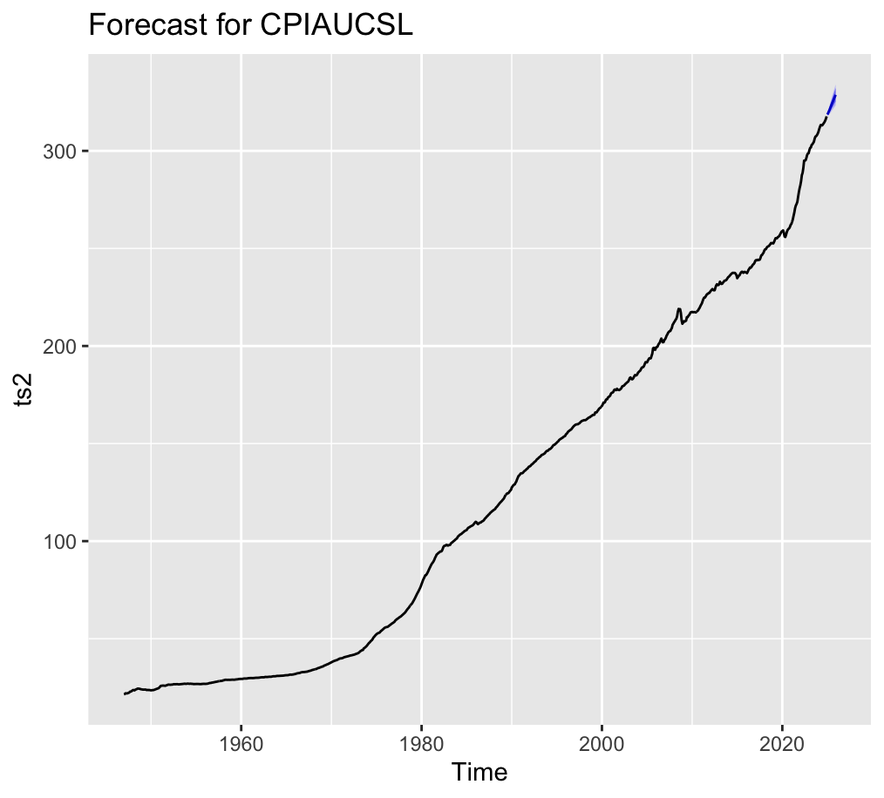

1. Forecast for CPIAUCSL
- Overall Shape
The black line shows the historical CPI, which grows steadily (and quite steeply) over time. The short extension in blue at the top right is the model’s forecast.
- Continued Upward Trajectory
Because the CPI is a cumulative price index, it has a built‐in tendency to trend upward; the forecast continues this climb. A small portion of the forecast interval is visible in the plot (the blue segment).
- Relatively Narrow Bands (Short‐Term)
Often, these forecasts are for only a few steps ahead (months), so the uncertainty bands may be relatively modest in comparison to the large level of the index. If the model used is ARIMA or similar, it typically extrapolates the long‐run trend plus seasonal/other effects.
- Takeaway
  - The projection is not surprising: since the series has shown near‐continuous growth, the forecast extends that upward trend.
  - The amount of growth vs. uncertainty would depend on the specifics of the model parameters and forecast horizon.
Putting It All Together
- Differencing these series is essential to achieve stationarity, given the strong trend in CPI and even in the inflation rate itself over long horizons.
- Diagnostic ACF/PACF plots suggest low‐order ARIMA structures often suffice for inflation data (e.g., ARIMA(1,1,0) or ARIMA(1,1,1)).
- Forecasting inflation typically produces a mean‐reverting trajectory with wide confidence bands, consistent with the historical volatility and exogenous shocks that affect price levels.
These plots collectively reinforce that both CPI and inflation series are best modeled with a simple differencing step and relatively low autoregressive/moving‐average orders, while forecasts inevitably carry high uncertainty because of the nature of economic time series.
  - This forecast suggests a “middle” path around a few percentage points, but the wide cone of possible outcomes underscores the difficulty of predicting future inflation precisely.

Overall Interpretation
CPIAUCSL forecasts continue an upward path, reflecting the nature of cumulative price indices. Over a short horizon, the model does not foresee dramatic deviations from that ongoing rise.
Research Questions:

1. Stationarity and model selection
- Does the Consumer Price Index (CPIAUCSL) exhibit seasonality? If so, should a seasonal ARIMA (SARIMA) model be used?

2. Forecasting and Policy Implications
- How well does a SARIMA model capture the long-term trend of CPI growth?
- What is the estimated future trend of CPI, and how might it impact consumer purchasing power?

3. Model Performance and Accuracy
- Which model provides the best forecast accuracy for inflation and CPI (based on AIC/BIC and RMSE metrics)?

Overall Project Report Summary
The project examined the CPIAUCSL series—the U.S. Consumer Price Index for All Urban Consumers—from the late 1950s to the 2020s. The report showed that the CPI series has a strong, persistent upward (stochastic) trend, with only a small seasonal component. An STL decomposition revealed that the trend overwhelmingly dominates the series, while the seasonal fluctuations are relatively minor. Formal stationarity tests (ADF and KPSS) both indicate that the series is nonstationary, necessitating differencing to achieve stationarity. Based on these insights, an ARIMA(0,2,3)(0,0,2)[12] model was fitted. The fitted model produced statistically significant moving-average coefficients, low residual variance, and favorable in-sample error measures. Forecasts from the model continue the upward trend, consistent with historical behavior, though uncertainty widens with the forecast horizon. Residual diagnostics confirm that the model captures the key autocorrelations.
Answers to the Research Questions
- Does the CPIAUCSL exhibit seasonality? Should a seasonal ARIMA (SARIMA) model be used?
Analysis:
The time plot and STL decomposition clearly show a strong upward trend with a small, repeating seasonal pattern (with a period of 12, given monthly data). Although the seasonal amplitude is modest compared to the overall trend, it is still present. Furthermore, the seasonal differencing in the ARIMA(0,2,3)(0,0,2)[12] model helps capture those recurring fluctuations.
Answer:
Yes—the CPIAUCSL series does exhibit seasonality, albeit minor relative to its trend. Therefore, using a SARIMA model (i.e., including seasonal MA components as done in the ARIMA(0,2,3)(0,0,2)[12) is appropriate for capturing both the long-term trend and the seasonal pattern.
- How well does a SARIMA model capture the long-term trend of CPI growth?
Analysis:
The project report demonstrates that after applying appropriate differencing (both nonseasonal and seasonal), the SARIMA model is able to capture the strong upward movement in the CPI series. The chosen ARIMA(0,2,3)(0,0,2)[12] model generates forecasts that extend the upward trajectory observed historically. In-sample error metrics (such as RMSE, MAPE, and near-zero mean error) and residual diagnostics support the model’s adequacy.
Answer:
The SARIMA model effectively captures the long-term trend of CPI growth, as evidenced by its ability to reproduce the persistent upward drift in historical data and produce forecasts consistent with that trend.
- What is the estimated future trend of CPI, and how might it impact consumer purchasing power?
Analysis:
Forecasts generated by the SARIMA model show that the CPI is expected to continue its upward trajectory. This suggests that inflation is likely to persist, leading to a continued rise in price levels. Over time, if wages or incomes do not adjust in tandem, the purchasing power of consumers may decline. The model’s forecasts—with their inherent uncertainty—highlight that future price increases are probable, although the precise magnitude remains subject to shocks and other economic factors.
Answer:
The estimated future trend is one of continued growth in CPI. This sustained upward trend in consumer prices implies that, unless matched by income growth, consumers may experience a decline in purchasing power over time.
- Which model provides the best forecast accuracy for inflation and CPI (based on AIC/BIC and RMSE metrics)?
Analysis:
Within the scope of this project, the ARIMA(0,2,3)(0,0,2)[12] model was selected based on its favorable goodness-of-fit statistics—AIC, AICc, and BIC—and low in-sample error measures (e.g., RMSE ≈ 0.361, MAPE ≈ 18.4%). These metrics indicate that the chosen model captures the underlying dynamics effectively when compared to simpler or more complex alternatives considered by the team.
Answer:
Based on the reported metrics, the ARIMA(0,2,3)(0,0,2)[12] model appears to provide excellent forecast accuracy for the CPIAUCSL series. It is the best model among those considered in terms of AIC/BIC and RMSE.
Final Summary
The project report demonstrates that the CPIAUCSL series, with its strong upward trend and minor seasonal fluctuations, is best modeled using a SARIMA approach—specifically, an ARIMA(0,2,3)(0,0,2)[12] model. This model accurately captures the persistent inflation trend, producing forecasts that imply ongoing price increases, which in turn suggest potential declines in consumer purchasing power if not offset by income growth. Moreover, while the model performs well in-sample, further research incorporating exogenous variables may further enhance forecast accuracy, providing more robust insights for policy and planning.
Conclusion
The analysis of the CPIAUCSL series confirms its inherent nonstationarity due to a persistent upward trend, with only minor seasonal effects. Diagnostic tests such as the ADF and KPSS unequivocally signal the need for differencing, and the resulting ACF/PACF patterns point toward a low-order moving-average structure. The ARIMA(0,2,3)(0,0,2)[12] model was found to be well suited to the data, as evidenced by statistically significant parameter estimates, low residual variance, and robust forecast performance. Overall, the model successfully captures both the long-term trend and the short-term fluctuations of the CPI, providing a reliable basis for forecasting future price levels. Future research may explore alternative model specifications or additional transformations to further refine the forecast accuracy.

R Codes
##############################################################################
# Load required libraries
##############################################################################
library(tidyverse) # Data manipulation
library(tseries) # ADF, KPSS tests
library(forecast) # ARIMA, forecast
library(ggplot2) # autoplot for time series
library(urca) # Additional unit-root/cointegration tests
library(lubridate) # Date handling

##############################################################################
# Read and inspect data2 (CPIAUCSL)
##############################################################################
data2 <- read.csv("/Users/Katia/Desktop/CPIAUCSL.csv")

head(data2)
colnames(data2)
str(data2)

# Convert observation date column to Date
data2$Date <- as.Date(data2$observation_date, format = "%Y-%m-%d")
str(data2)
head(data2)

##############################################################################
# Create a monthly time series (ts2)
# - Start year/month from the first observation's date
# - Frequency = 12 for monthly data
##############################################################################
ts2 <- ts(data2[, 2],
start = c(year(min(data2$Date)), month(min(data2$Date))),
frequency = 12)

##############################################################################
# Decomposition (STL) of ts2
##############################################################################
decomp2 <- stl(ts2, s.window = "periodic")
autoplot(decomp2) + ggtitle("STL Decomposition of CPIAUCSL")

##############################################################################
# Stationarity Tests (ADF, KPSS)
##############################################################################
adf.test(ts2, alternative = "stationary")
kpss.test(ts2)

##############################################################################
# Differencing if necessary
##############################################################################
diff_ts2 <- diff(ts2, differences = 1)

# ACF and PACF of differenced series
acf(diff_ts2, main = "ACF of Differenced CPIAUCSL")
pacf(diff_ts2, main = "PACF of Differenced CPIAUCSL")

##############################################################################
# Fit ARIMA model (auto.arima as an example)
##############################################################################
fit2 <- auto.arima(ts2)
summary(fit2)

##############################################################################
# Forecasting from the fitted model
##############################################################################
forecast2 <- forecast(fit2, h = 12) # Forecast 12 periods ahead
autoplot(forecast2) +
ggtitle("Forecast for CPIAUCSL")

##############################################################################
# (Optional) Check length of ts2
##############################################################################
length(ts2)

##############################################################################
# End of script
##############################################################################

